**OSMS WEBSITE**

A desertion submitted in partial fulfillment of the requirements for the award of degree

**(Bachelor of Computer Applications)**

By

# MIR KASIM ALI NAQVI

**REG. NO.: 1713181033029**

UNDER THE GUIDANCE OF

## Prof. H.RIAZ AHAMED, M.C.A, M.Phil,

Assistant Professor



**DEPARTMENT OF COMPUTER APPLICATIONS**

### THE NEW COLLEGE (AUTONOMOUS)

**CHENNAI - 600014**

**DEPARTMENT OF COMPUTER APPLICATIONS**

**THE NEW COLLEGE (AUTONOMOUS)**

**CHENNAI - 600014**



**BONAFIDE CERTIFICATE**

This is to certify that the project work Entitled “**OSMS**​ **WEBSITE**”​ is a bonafide record work done by **Mr.**​ **MIR KASIM ALI NAQVI**,​ **Reg.**​ **No.: 1713181033029**

in a partial fulfillment of the requirement for the award of the Degree of Bachelor of Computer Applications.

Project Guide Head of the Department

Submitted for the Viva Voce Examination held on …………....

Internal Examiner External Examiner

Place :

Date :

**ACKNOWLEDGEMENT**

### “In the name of Allah, the most Beneficent, the most Merciful”

I would like to thank our **Principal**​ **Dr. A. ABDUL JABBAR, M.Sc., M.Phil., Ph.D., D.C.A., F.I.C.S. Hon. Dip. in S.T.S.M,** for his guidance.​

I thank **Mr.​ M. I. SEYADU UMAR FAROOK, M.C.A., M.Tech., M.Phil., Head of the Department,** for his guidance and helpful mind to complete this

project.

I am extremely grateful to my project guide **Prof.**​ **H.RIAZ AHAMED, M.C.A, M.Phil, Assistant Professor** **of**​ **Computer Application,** for suggesting to me the guidance at the right time and discussions on a very useful topic needed in the course of the work.

I'm also grateful to **all**​ **the staff of the Department of Computer Applications.** My heartfelt thanks goes to **my**​ **parents and friends** who encouraged me to do this mini project, and only because of their Best wishes and invaluable help, this project is seeing the light of the day.

**Table of Contents**

|  |  |  |
| --- | --- | --- |
| **S.No** | **Contents** | **Page No.** |
| 1. | Introduction | 1 |
| 2. | System Analysis | 6 |
| 3. | Requirement Specification | 9 |
| 4. | System Design | 11 |
| 5. | Software Description | 17 |
| 6. | System Testing And Implements | 24 |
| 7. | ER Diagram | 31 |
| 8. | Table Structure | 33 |
| 9. | Form Layout | 39 |
| 10. | Data Reports | 45 |
| 11. | Source Code | 49 |
| 12. | Conclusion | 55 |
| 13. | Future Enhancement | 57 |
| 15. | Bibliography | 59 |



## ABOUT THE PROJECT

I have developed Online Service Management System project. This application can be used in any Service Centre who wants to support their customers online. Customer do not need to visit service center for service request they can use this portal and can request for service online at home in the other hand service provide can approve or disapprove customer's service request from his own Panel. This application will help requester and admin in their day to day working life

The project contains modules namely are ;-

**Modules**

1. Home
2. Services
3. Registration
4. Contact
5. Login

6. User Panel

⦁ Profile

⦁ Submit Request

⦁ Service Status

⦁ Change Password

⦁ Logout

⦁ Admin Login

**Admin Module:**

1. Dashboard
2. WORK ORDER
3. REQUEST
4. ASSETS
5. TECHNICIAN
6. REQUESTER
7. SELL REPORT
8. WORK REPORT
9. CHANGE PASSWORD

10. LOGOUT

Admin can also change his /her own password.

**Home**:

This module of the web portal contains all the links of the system such as Services, Contact Us, Registration, Login, User Panel, Admin Panel, Technician, Requester, Sell Report, Work Report, Change Password, Logout.

**Services:**

This module describes which services company provides to its customers.

**Registration**:

This System which provides a Registration form where user/requesters can register themselves and submit Service Requests.

**Contact**:

By this module of the web portal the user can contact us.

**Login**:

This module is used to login/signup in the list of the Online Service Management System.

**User Panel**

This module contains a Profile, Submit Request, Service Status, Change Password, Logout, Admin Login etc.

**Profile:**

User can see their register email id and Name as well as if they wish to change the name, they can update new Name. The Registered Email ID is read only so it can’t be altered.

**Submit Request: -**

Using this module user can submit service request. It is necessary to fill up all the details asked in the form. After submitting form user will get an receipt which he can print out.

**Service Status: -**

User can check their service request status by filling up service request id

**Change Password: -**

User can change his/her login password.

**Logout: -**

This Logout and Exit the Application.

**Admin Login:**

This is Admin login form. When Admin clicks on this link an Admin login form will be appear where admin can enter their email id and password for logging in to the Admin panel

**Admin Panel**:

This module contains a Dashboard, Work Oder, Requests, Assets etc.

**Dashboard: -**

This screen displays overview of work and other stuff like Number of technician and list of requesters.

**Work Oder: -**

This page contains all the assigned request made by users. Admin can view or delete the assigned work as per their need.

**Requests: -**

This is the most important module of admin panel where admin can assign the work/requests made by users/requesters. If there is any invalid request admin can delete that request without assigning them.

**Assets: -**

The main work is to accomplish in this module is to add, modify or remove any assets of the Service centre. This contains few sub modules through which works are performed. These are as follows:

* New: This is used to add new Product Part in the service centre. There is a Plus (+) sign button which is actually New Button.
* Edit: This sub module is used to modify the existing details of the Product if anything goes changes in their record. There is a Pencil button which is actually Remove Button.
* Remove: This is used to remove any product from the service centre. There is a Trash button which is Remove Button.
* Sell: This is used when going to sell a product Admin can also print out a bill for customer.

**Technician: -**

The main work is to accomplish in this module is to add, modify or remove Technician of the Service centre. This contains few sub modules through which works are performed. These are as follows:

* New: This is used to add new Technician details in the service centre. There is a Plus (+) sign button which is actually New Button.
* Edit: This sub module is used to modify the existing details of the Technician if anything goes changes in their record. There is a Pencil button which is actually Remove Button.
* Remove: This is used to remove Technician from the service centre. There is a Trash button which is Remove Button.

**Requester: -**

The main work is to accomplish in this module is to add, modify or remove Requesters/Users. This contains few sub modules through which works are performed. These are as follows:

* New: This is used to add new Requesters details in the service centre database. There is a Plus (+) sign button which is actually New Button.
* Edit: This sub module is used to modify the existing details of the Requester if anything goes changes in their record. There is a Pencil button which is actually Remove Button.
* Remove: This is used to remove Requester from the service centre.

There is a Trash button which is Remove Button.

**Sell Report: -** This module is used to view and print sell report.

**Work Report: -** This module is used to view and print Work report.

**Change Password: -**  User can change his/her login password.

**Logout:** This Logout and Exit the Application.



**INTRODUCTION**

OSMS is India’s leading chain of multi-brand Electronics and Electrical service workshops offering wide array of services. We focus on enhancing your uses experience by offering world-class Electronic Appliances maintenance services. Our sole mission is “To provide Electronic Appliances care services to keep the devices fit and healthy and customers happy and smiling”. With well-equipped Electronic Appliances service centers and fully trained mechanics, we provide quality services with excellent packages that are designed to offer you great savings. Our state-of-art workshops are conveniently located in many cities across the country.

Today’s customers don’t just expect high quality and excellent service at a fair price — they demand it. Luckily, today we know far more about how to provide people with the experience they want. And it all begins with Online Service Management System

**USER PERFORMANCE**

Before developing any computerized system it is important to examine the problems in the existing system and the additional information that should be fulfilled in the proposed system. In the present system we can be able to insert the customer details.



**HARDWARE REQUIREMENTS**

PROCESSOR : INTEL i3-6006U 6TH GEN

PROCESSOR SPEED : 2.4 GHz

RAM : 4 GB

MONITOR : 1080 FULL HD LED DISPLAY

KEYBORD : NOTEBOOK KEYBORD

OPERATING SYSTEM : WINDOWS 10

HDD : 1 TB

MOUSE : MOUSEPAD TRACK

**SOFTWARE REQUIREMENTS**

FRONT END : visual studio

BACK END : MySQL

OPERATING SYSTEM : WINDOWS 10



## INTRODUCTION

System design is a transition which goes through logical and

physical design with emphasis on preparing input/output specification. Specify implementation plan preparing a logical design before

implementation. After this, the logical design, the requirements are to be translated in terms of hardware, software, equipment that is program

software, database files, text files and the working files were produced, the physical design.

## PHYSICAL DESIGN

​Physical design deals with reviewing the correct physical

system and its requirements. Once the requirements are studied then an output specification is prepaid from that of the problem. It’s feasibility is studied. The application is designed logically based on the requirement and feasibility is accessed.

## LOGICAL DESIGN

Logical design is nothing but system specification. Logical

designs, they specify the user needs at a level of detail that virtually determines the information flow into and out of the system.

Review the correct physical system: it’s volumes, frequencies, and designs.

Prepare output screen specifications: it determines the format,

connection, and frequency of results, including terminal specifications and locations.

Specifies the implementation plan

Prepare a logical design walkthrough of the input screen, and implementation plan.

Reviews benefits, costs, target results and system constraints.

The logical design also specifies output screen, input screen.

### INPUT DESIGN

​In accurate input data are the most common cause of errors in data processing. Input design is the process of converting user-originated inputs into a computer-based format. The goal of designing is to make data entry as easy, logical and free errors as

possible.

In the manual system, paper forms are used to collect information.

So to have compatibility, the electronic form is designed to

be like the original form for pacing requests.

The input design incorporates as much automation as possible.

The inputs are validated when required.

An important part in input design is the checking for incomplete forms. Blank fields do not cause wrong data but incomplete data is equally harmful as the bad data. Before the document is saved it is

checked for the existence of any blank fields.

The input forms are designed to be user friendly. Meaningful and

labels are given to the input fields. Immediate validation is done for each

input form the user that the invalid inputs are not sent to the database.

The input forms are designed so that they provide the proper

links to other forms. Provisions have been given to go back to the main

menu as and when required.

### FORM DESIGN

**MAIN MENU MODULE (MULTIPLE DOCUMENT INTERFACE)**

​This contains different menus, which have different tabs. The

user can enter the menu or home module only when the password and username is matched and authenticated from the database.

### OUTPUT DESIGN

Computer outputs are the most important and direct of

information to the administrator. They are encountered everywhere in everyone’s day-to-day life. The usefulness and clarity of such common place outputs depend a great deal on that care with which an analyst designed them, keeping their major purpose in mind. Every kind of

business produces some kind of reports, and many systems produce a lot.

The screens for the display of the action of Billing report, Customer report, Item report, and complete report, that the output are provided to the administrator can view the form. The design of the output screens include that they are complete with all necessary information requested for. The administrator displays the complete summary of the output depending on the option.

### CODE DESIGN

Once the output requirements are determined, the system

designer can decide what to include in the system and how to structure it and the requirements output can be produced. The output forms or the screen used in the system are required for viewing and reporting the system.

### TYPES OF CODE

The​ common purpose of code is to classify objects for analysis. They are also used for feeding the user details and the user can browse the details on the home page. Login code type is also available in this project.



**ABOUT THE FRONT-END:**

### VISUAL STUDIO CODE (VSC) CODE EDITOR

**Visual**​ **Studio Code** is a source-code editor developed by Microsoft for Windows, Linux and macOS. It includes support for debugging, embedded Git control and GitHub, syntax highlighting, intelligent code completion, snippets, and code refactoring. It is highly customizable, allowing users to change the theme, keyboard shortcuts, preferences, and install extensions that add additional functionality. The source code is free and open source and released under the permissive MIT License. The compiled binaries are freeware and free for private or commercial use.

The visual studio code environment is great for creating almost any type of application you can think of. You can develop robust stand-alone applications, games and utilities in less than it takes in other languages. You can also use ActiveX technology to create Internet-enabled applications that are limited only by our imagination. When used in conjunction with the windows API, you are armed with a serious programming tool for which you can do almost anything in your project development efforts.

### DEVELOPMENT LANGUAGES, SCRIPTS AND LIBRARIES

**HTML:**​HTML,​ or Hypertext Markup Language, is used to create web pages. Site authors use HTML to format text as titles and headings, to arrange graphics on a webpage, to link to different pages within a website, and to link to different websites.

HTML is a set of codes that a website author inserts into a plain text file to format the content. The author inserts HTML tags, or commands, before and after words or phrases to indicate their format and location on the page. HTML tags are also used to add tables, lists, images, music, and other elements to a webpage.

**CSS:**​ CSS​ is the language for describing the presentation of Web pages, including colors, layout, and fonts. It allows one to adapt the presentation to different types of devices, such as large screens, small screens, or printers. CSS is independent of HTML and can be used with any XML-based markup language. The separation of HTML from CSS makes it easier to maintain sites, share style sheets across pages, and tailor pages to different environments. This is referred to as the *separation of structure (or: content) from presentation.*​

**BOOTSTRAP:**​ Bootstrap​ is a free and open-source CSS framework directed at responsive, mobile-first front-end web development. It contains CSS- and (optionally) JavaScript-based design templates for typography, forms, buttons, navigation, and other interface components.

Bootstrap is a web framework that focuses on simplifying the development of informative web pages (as opposed to web apps). The primary purpose of adding it to a web project is to apply Bootstrap's choices of color, size, font and layout to that project. As such, the primary factor is whether the developers in charge find those choices to their liking. Once added to a project, Bootstrap provides basic style definitions for all HTML elements. The result is a uniform appearance for prose, tables and form elements across web browsers. In addition, developers can take advantage of CSS classes defined in Bootstrap to further customize the appearance of their contents. For example, Bootstrap has provisioned for light- and dark-colored tables, page headings, more prominent pull quotes, and text with a highlight.

Bootstrap also comes with several JavaScript components in the form of jQuery plugins. They provide additional user interface elements such as dialog boxes, tooltips, and carousels. Each Bootstrap component consists of an HTML structure, CSS declarations, and in some cases accompanying JavaScript code. They also extend the functionality of some existing interface elements, including for example an auto-complete function for input fields.

**JAVASCRIPT (JS):**​ Along​ with HTML and CSS, JavaScript forms the basis of front-end web development, allowing the creation of interactive elements. **JavaScript,** which​ is the focus of this tutorial. JavaScript allows you to take ordinary web elements and make them interactive. It can be used alongside your HTML and CSS and is an extremely important tool for any web developer. To complete the example above, JavaScript code would be used to make your login button perform the required actions (logging a user in when it is clicked).

### ABOUT BACK END

**PHP**

Every PHP is an open source language and all its components are free to use and distribute. PHP is server-side scripting language. It is embedded in HTML source code. It is used to generate dynamic pages content. People find it useful to develop websites and dynamic web pages. It is platform independent. PHP supports all major web servers such as Apache, Microsoft IIS and Netscape etc. All the major database such as Mysql, PostgreSQL, Oracle, Sybase, Microsoft SQL Server is supported by PHP. The main reasons for using PHP language are:

1. It collects form data and save data send by mail.
2. It sends and receives cookies by accessing cookies variables.
3. It provides add, delete and modify element function within our database.
4. Through PHP, we can restrict users to access some pages of our website.
5. It can encrypt data, so that our data will become more secure.

**MySQL**

Mysql is the most popular open source relational database management system .It is one of the best RDBMS being used to develop web-based software applications. It is easy to use and fast RDBMS. There are many good reasons which help us to develop website using this RDBMS:

* It is open-source, so available for free.
* It works on many operating system and with many languages including PHP, PERL, C, C++ etc.
* Mysql is customizable.
* Mysql works very friendly to PHP.

Mysql works very quickly and works well even with large data sets

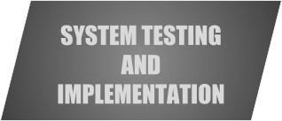

### IMPLEMENTATION

​The crucial phase in the system life cycle is successful completion of the new system design. Implementation simply means converting a new system design in to operation

This involves creating files, training the operation staff and

installing the hardware and telecommunication network before the system is up and running. A Crucial factor in the conversion is not disrupting the functioning of the organization. In system implementation user training is essential.

The user manual is prepaid reflexively because it is an item that must accompany every system. The manual is necessary when the user uses geographically, remote from the project team or what they

cannot attend all training sessions.

### TESTING

Testing is the major quality measure employed during software

development. After the coding phase, computer programs are available that can be executed for testing purposes. Testing not only has to uncover errors introduced during coding, but also locates errors during the previous phases. Thus the aim of testing is to uncover requirements, design or coding errors in the program.

System testing is an expensive but critical process that can take us as much as fifty percent of the budget for the programs development. Consequently, different levels of testing are employed. In fact, a successful test is one that finds as error .The system performance criteria deal with turnaround time, back up, file protection and human factor. A test for user acceptance should also be carried out.

### TESTING STRATEGY

​This is the phase where bugs in the programs were to be found

and corrected. One of the goals during dynamic testing is to produce a test suite, where the salary calculated with the desired outputs such as reports in the case. This is applied to ensure that the modification of the program does not have any side effects. This type of testing is called regression testing. Testing generally relieves all the residual bugs and removes the bugs and improves the reliability of the program.

### TYPES OF TESTING

The basic types of testing that can done in this project is

* Unit testing
* Integration testing
* Validation testing
* Output testing
* User acceptance testing

### UNIT TESTING

​This is the first level of testing. In this different modules are tested against the specifications produced the design of the modules. Unit testing is done for the verification of the code produced during the coding of a single program module is an isolated environment. Unit testing first focuses on the modules independently of one another to locate errors.

After coding, each dialog is tested and run individually. All unnecessary coding was removed and ensured that all the modules worked, as the programmer would expect. Logical errors found were corrected. So by working all the modules independently and verifying the outputs of each module in the presence of staff it was concluded that the program was functioning as expected.

### INTEGRATION TESTING

​Data can be lost accessing an interface, one module can have as adverse effort on the other sub function when combined may not produce the desired major functions. Integration testing is systematic testing for constructing the program structure, while at the same time conducting tests to uncover errors associated with the interface. The objectives are to take a unit tested as a whole. Here the correction is difficult because vast expenses of the entire program complicate the isolation of causes. Thus in the integration testing step, all the errors are uncovered and are corrected for the next testing steps.

### VALIDATION TESTING

​This provides the final assurance that the software meets all functional, behavioral and performance requirements. The software is completely assembled as a package. Validation succeeds when the

software functions in manner in which the user expects. Validation refers to a processor using software in a live environment in order to find errors. During the course of validating the system, failures may occur and sometimes the coding has to be changed according to the requirement. Thus the feedback from the validation phase generally produces changes in the software. Once the application was made free of all logical and interface errors, inputting dummy data ensured that the software developed satisfied all the requirements of the user.

### OUTPUT TESTING

​After performing the validation testing, the next step is output testing of the proposed system since no system could be useful if it does not produce the required output generated or considered in two ways; one is on screen and another is printed format.

The output format on the screen is found to be correct as the

format was designed in the system design phase according to the user's needs. For the hard copy also the output comes out as the specified requirements by the user hence output testing does not result in any

correction in the system.

### USER ACCEPTANCE TESTING

User acceptance of a system is the key factor for the success of any system. The system under consideration is tested for user acceptance by constantly keeping in touch with the prospective system users at the time of developing and making changes whenever required.

Preparation of test data plays a vital role in the system testing. After preparing the test data the system under study is tested using the test

data. While testing the system by using test data errors are again

uncovered and the corrections are also noted for future use.

### TEST DATA

After preparing the test data the system under study was tested

using test data. While testing the system by using test data, errors were

again uncovered and corrected by using the above testing steps. Preparation of Test data plays a vital role in the system testing. Taking various types of test data does all the above testing.

### TESTING EXECUTION

​Test data was prepared which were the acknowledgement

details and the information regarding the various departments in the case. An already existing file was taken from the database and the data was fed into the new system. Various tests as mentioned above were carried out. Initially there were bugs and drawbacks for the user to complete the same process. Those bugs and drawbacks were noted down and modified later.

Again the same process was repeated three to four times. All the outputs



**ER Diagram:**

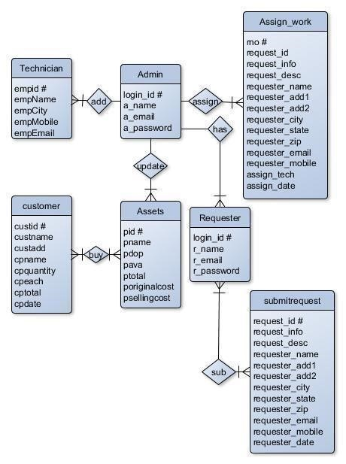



**Table Name: adminlogin_tb**

|  |  |  |
| --- | --- | --- |
| **z** | **Data Type** | **Description** |
| a_login_id # | int | Stores login id (Automatically Generated) |
| a_name | varchar(60) | Stores Name |
| a_email | varchar(60) | StoreEmail |
| a_password | varchar(60) | Store Password |

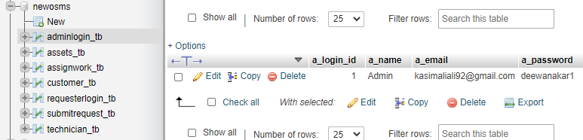

|  |  |  |
| --- | --- | --- |
| **Attribute** | **Data Type** | **Description** |
| r_login_id # | int | Stores login id (Automatically Generated) |
| r_name | varchar(60) | Stores Name |
| r_email | varchar(60) | StoreEmail |
| r_password | varchar(60) | Store Password |

**Table Name: requesterlogin_tb**

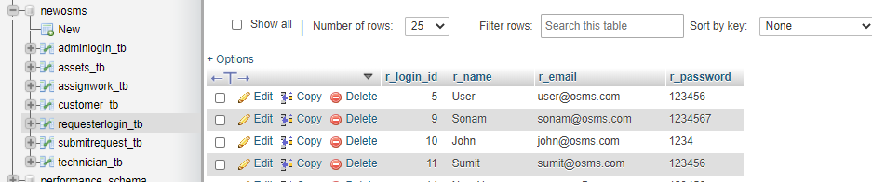

**Table Name: customer_tb**

|  |  |  |
| --- | --- | --- |
| **Attributes** | **Data Type** | **Description** |
| custid # | int | Customer ID (Automatically Generated) |
| custname | varchar(60) | Customer Name |
| custadd | varchar(60) | Customer Address |
| cpname | varchar(60) | Product Name |
| cpquantity | int | Product Quantity |
| cpeach | int | Each Quantity Price |
| cptotal | int | Total Price |
| cpdate | date | Selling Date |

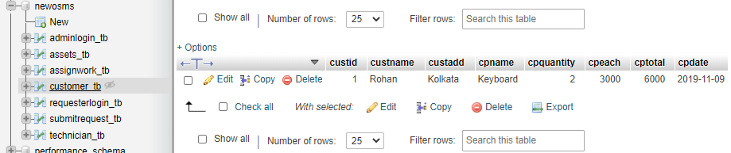

**Table Name: assets_tb**

|  |  |  |
| --- | --- | --- |
| **Attributes** | **Data Type** | **Description** |
| pid # | int | Product ID (Automatically Generated) |
| pname | varchar(60) | Product Name |
| pdop | date | Product Date |
| pava | int | Number of Available Product |
| ptotal | int | Number of Total Product |
| poriginalcost | int | Product Original Cost |
| psellingcost | int | Product Selling Price |

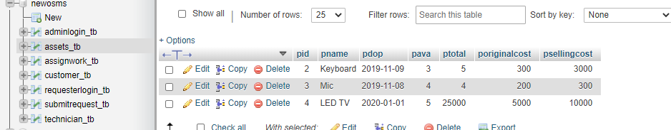

**Table Name: submitrequest_tb**

|  |  |  |
| --- | --- | --- |
| **Attributes** | **Data Type** | **Description** |
| request_id # | int | Request ID (Automatically Generated) |
| request_info | text | Request Info |
| request_desc | text | Request Description |
| requester_name | varchar(60) | Requester Name |
| requester_add1 | text | Requester Address Line 1 |
| requester_add2 | text | Requester Address Line 2 |
| requester_city | varchar(60) | Requester City |
| requester_state | varchar(60) | Requester State |
| requester_zip | int | Requester Zip |
| requester_email | varchar(60) | Requester Email |
| requester_mobile | bigint | Requester Mobile |
| request_date | date | Request Date |

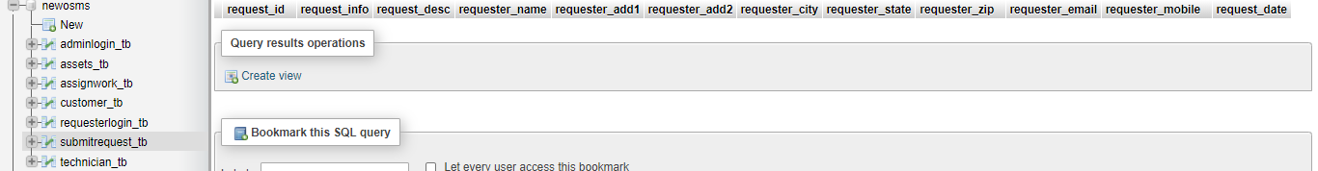

**Table Name: assignwork_tb**

|  |  |  |
| --- | --- | --- |
| **Attributes** | **Data Type** | **Description** |
| rno # | int | Request Number (Automatically Generated) |
| request_id | int | Request ID |
| request_info | text | Request Info |
| request_desc | text | Request Description |
| requester_name | varchar(60) | Requester Name |
| requester_add1 | text | Requester Address Line 1 |
| requester_add2 | text | Requester Address Line 2 |
| requester_city | varchar(60) | Requester City |
| requester_state | varchar(60) | Requester State |
| requester_zip | int | Requester Zip |
| requester_email | varchar(60) | Requester Email |
| requester_mobile | bigint | Requester Mobile |
| assign_tech | varchar(60) | Assign Technician Name |
| assign_date | date | Assigned Date |

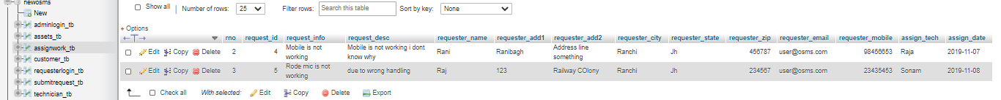

**Table Name: technician_tb**

|  |  |  |
| --- | --- | --- |
| **Attributes** | **Data Type** | **Description** |
| empid # | int | Employee ID (Automatically Generated) |
| empname | varchar(60) | Employee Name |
| empcity | varchar(60) | Employee City |
| empmobile | bigint | Employee Mobile Number |
| empemail | varchar(60) | Employee Email ID |

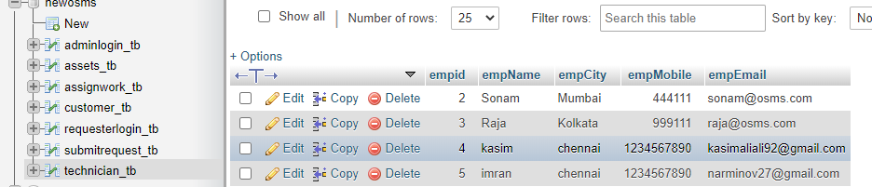



**User sing-up:**

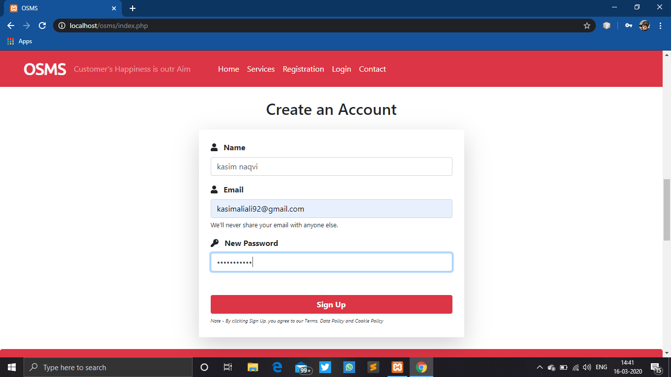

**User login:**

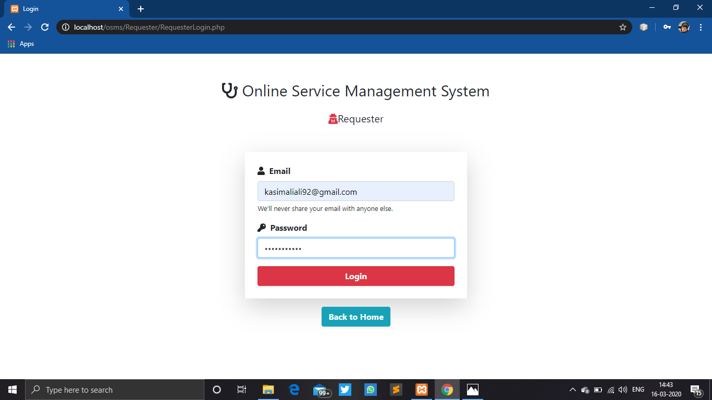

**Admin login:**

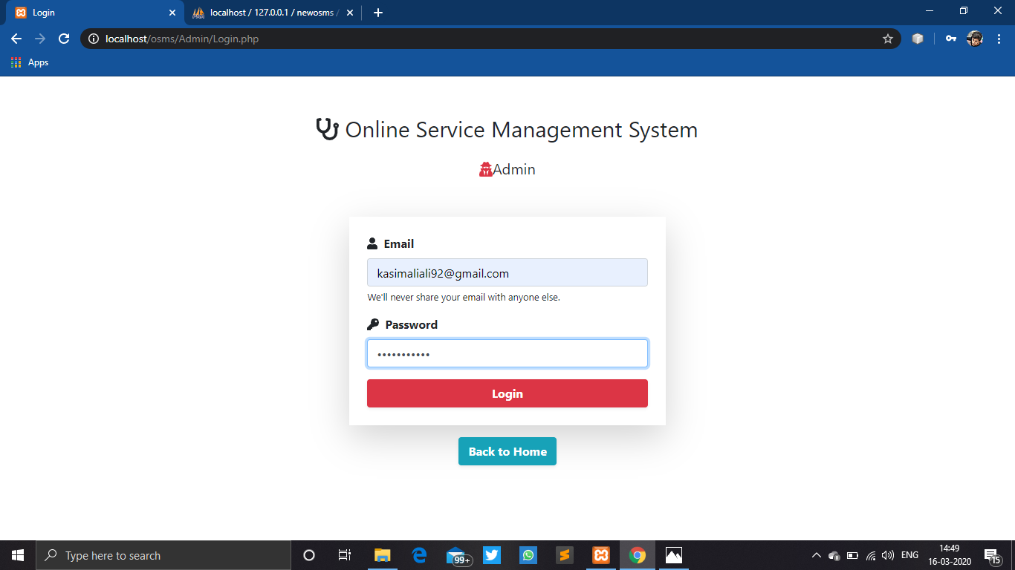

**Contact us form:**

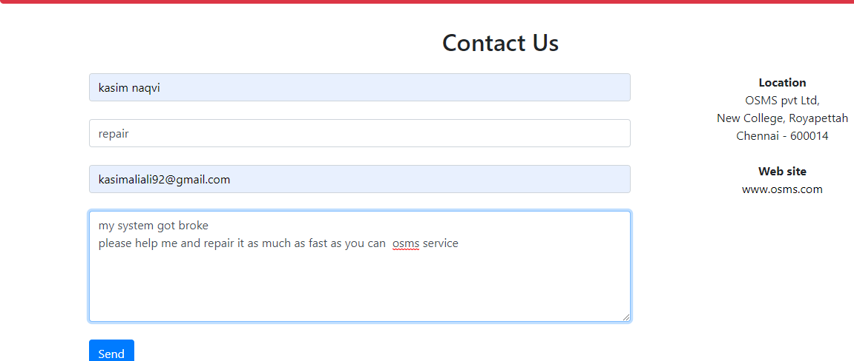



### REGISTERED USERS:

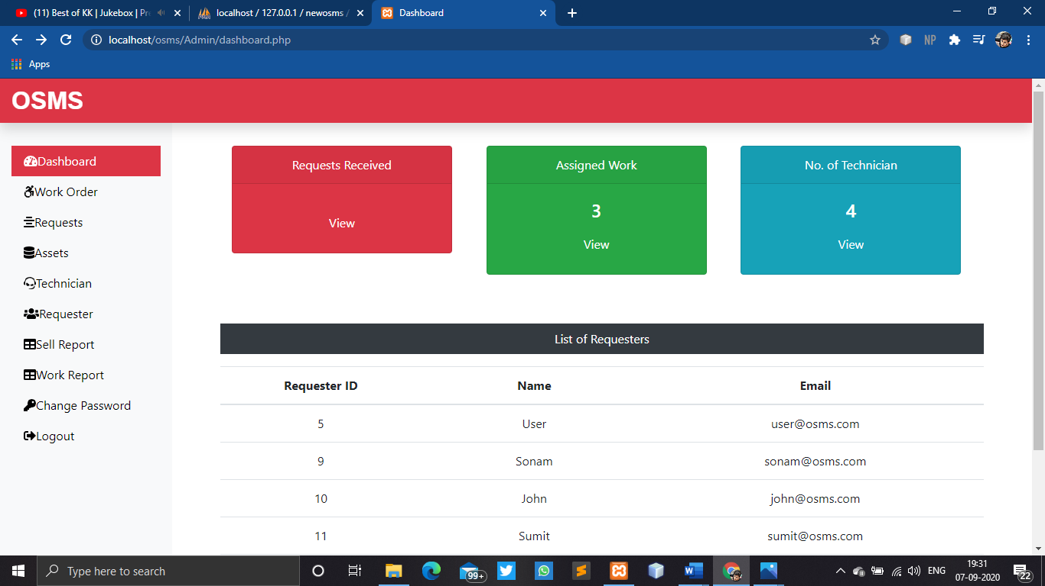

### Assigned Work Details:

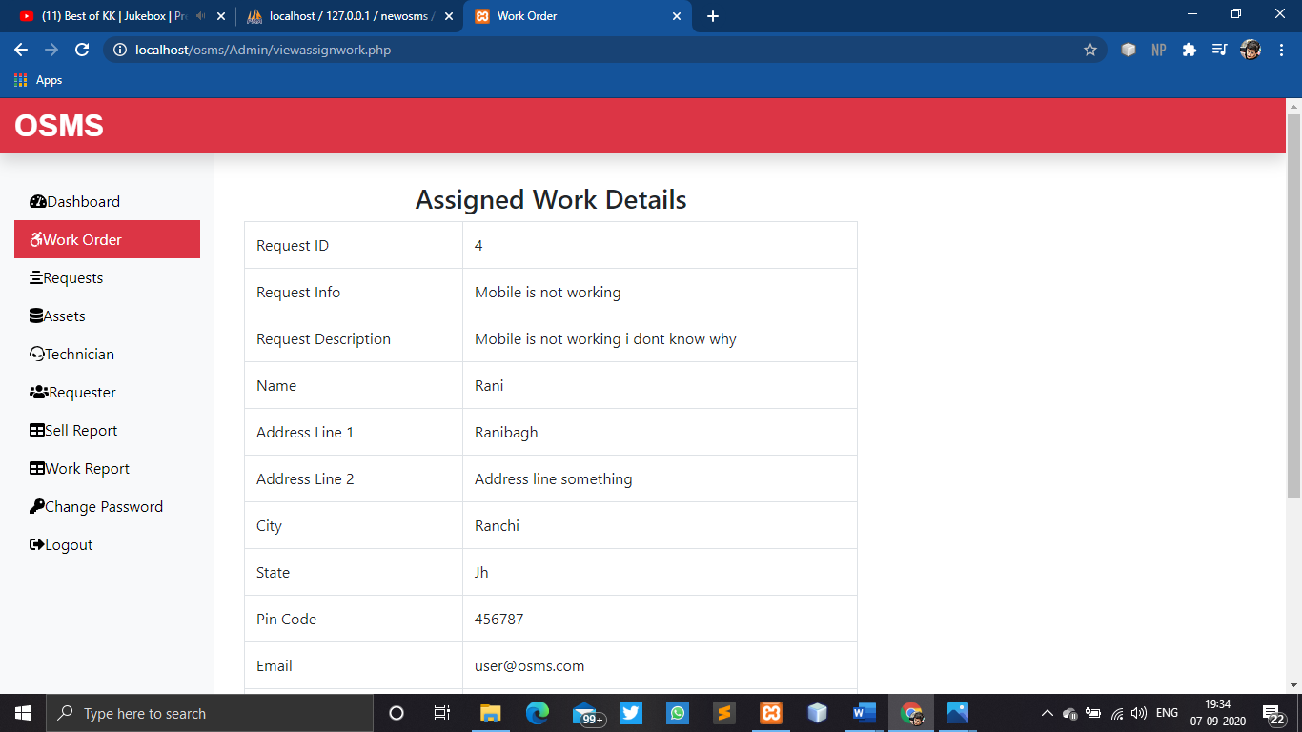

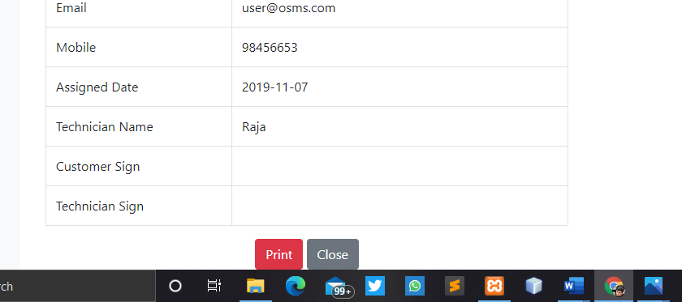

**WORK REPORT:**

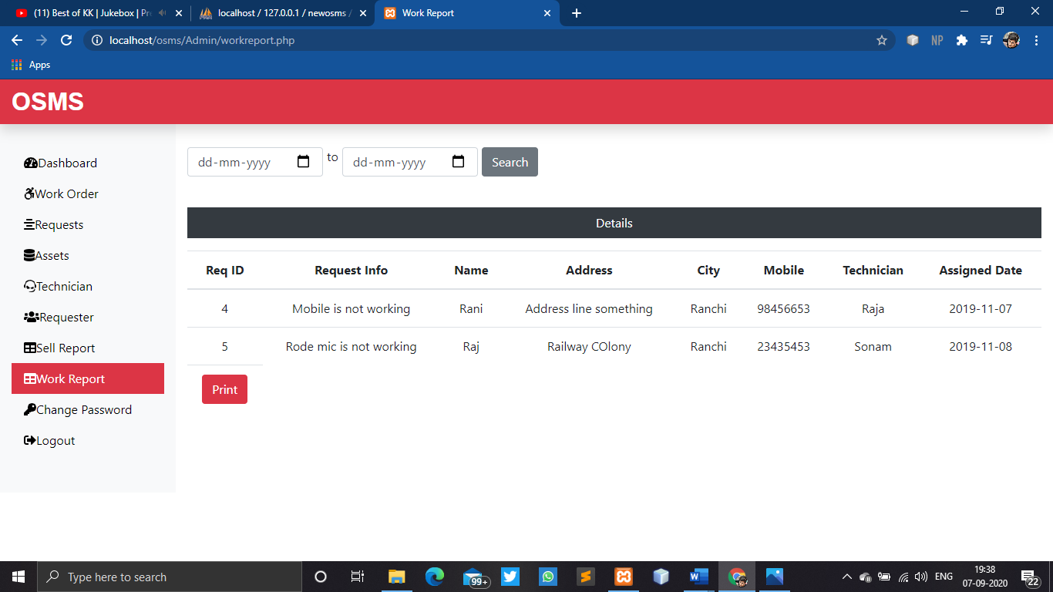



**LOGIN CODE:**

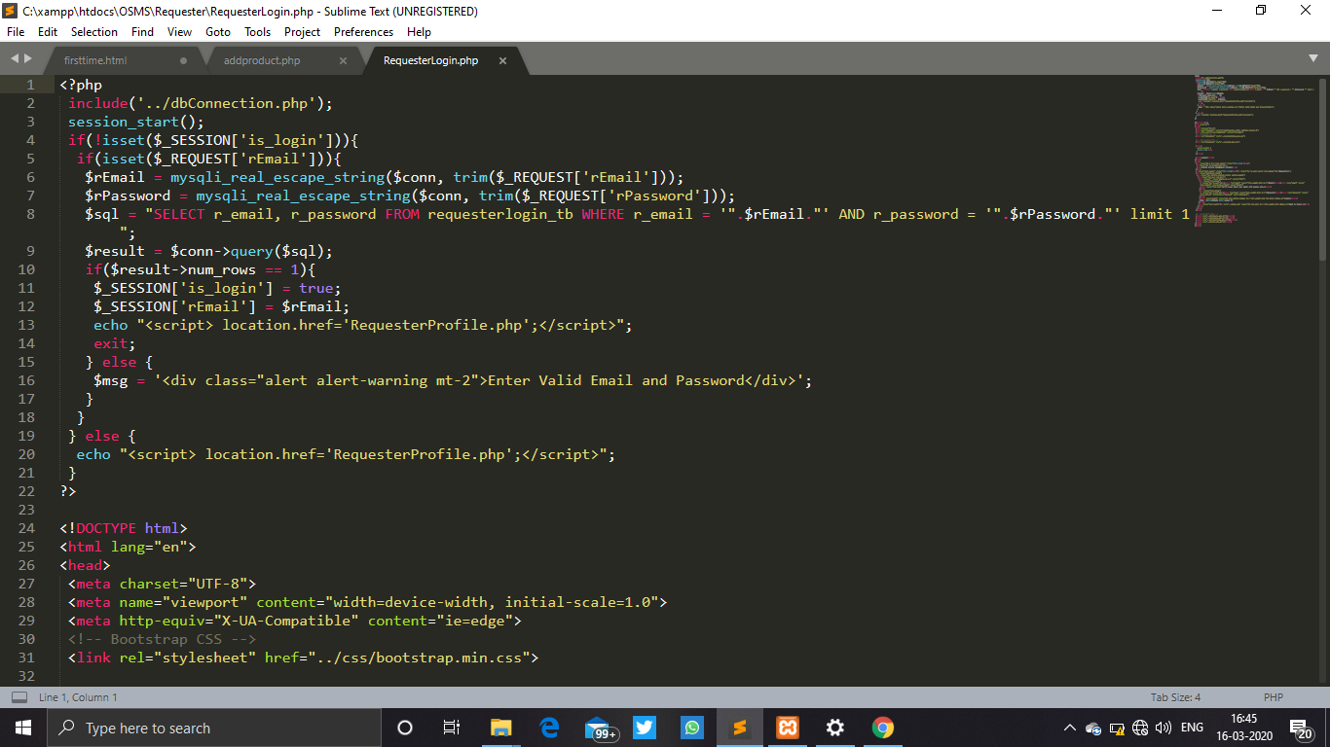

**LOGOUT CODE:**

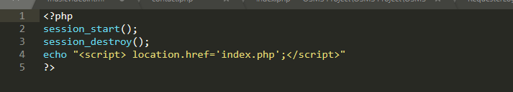

### REGISTRATION CODE:

### 

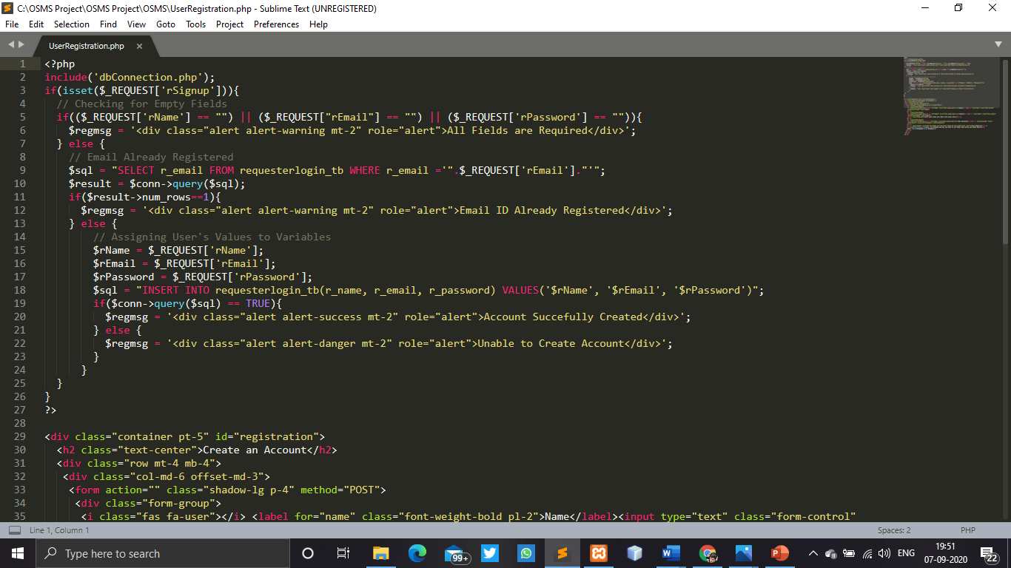

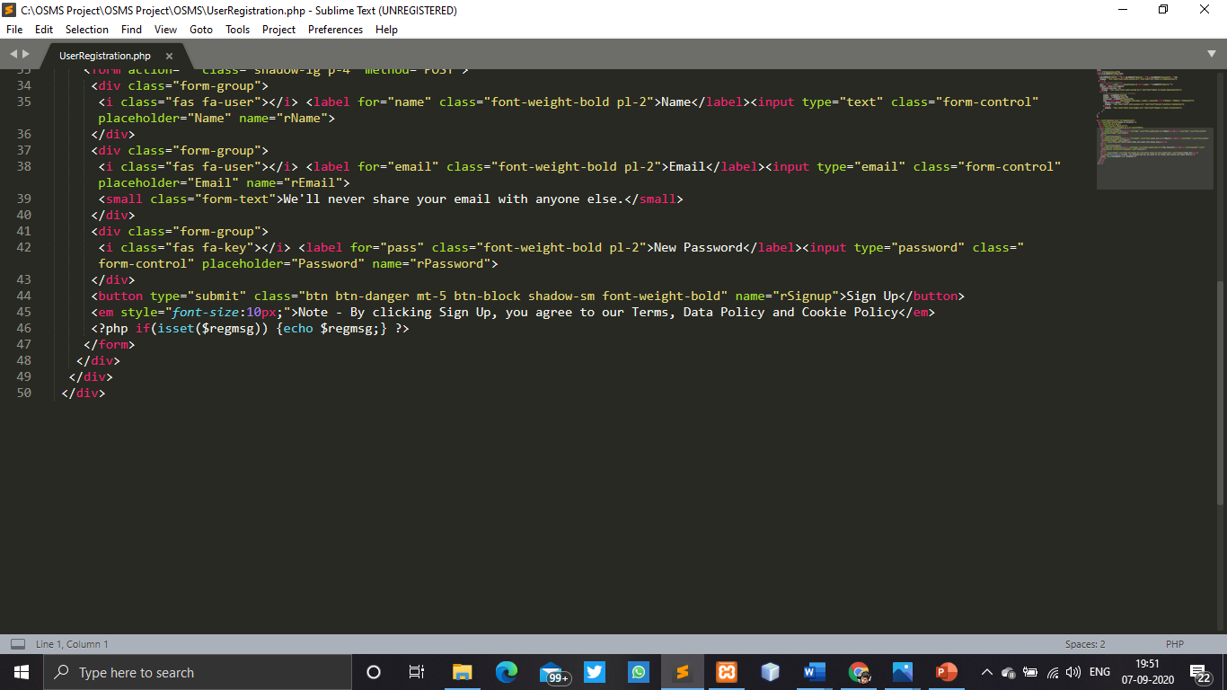



### CONCLUSION :

The Online Service Managment System has been computed successfully and was also tested successfully by taking "Test Cases". It is user friendly, and has required options, which can be utilized by the user to perform the desired operations.

The Software is developed using HTML, CSS, JS as front end and PHP, MySql as back end in windows environment. The goals that are achieved by the software are:

* Simplification of the operations
* Less processing time and getting required information
* User friendly
* Portable and flexible for further enhancement



### FUTURE ENHANCEMENT:

The various things can be made it simple and user friendly. As by increasing some of the coding we can improve it functionality. online payment system is yet not integrated to the system which can be featured in the near future. Till now it does not have the facility of back up the database. By as the next advancement we can make it able to bundle the backup facility so that one can perform operation based on previous records.

As the technology emerges, it is possible to upgrade the system and can be adaptable to desired environment.

Based on the future security issued, security can be improved using emerging technologies.



### BIBLIOGRAPHY

### BOOKS

The following reference has been used to develop the project “Online Service Managment System” :-

**Books: -**

* The Complete Reference PHP
* Head First SQL: Your Brain on SQL by Lynn Beighley

**Web Source: -**

* www.google.co.in
* www.w3school.com
* www.tutorialspoint.com
* www.stackoverflow.com
* www.docs.microsoft.com